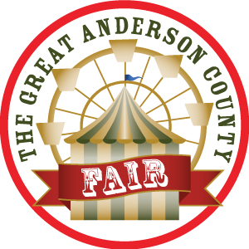
The Great Anderson County Fair
2024 Photo Kit
For Media info: missy@jrmmanagement.com
Thegreatandersoncountyfair.com
864-309-6618

- The magical Seattle Wheel at night
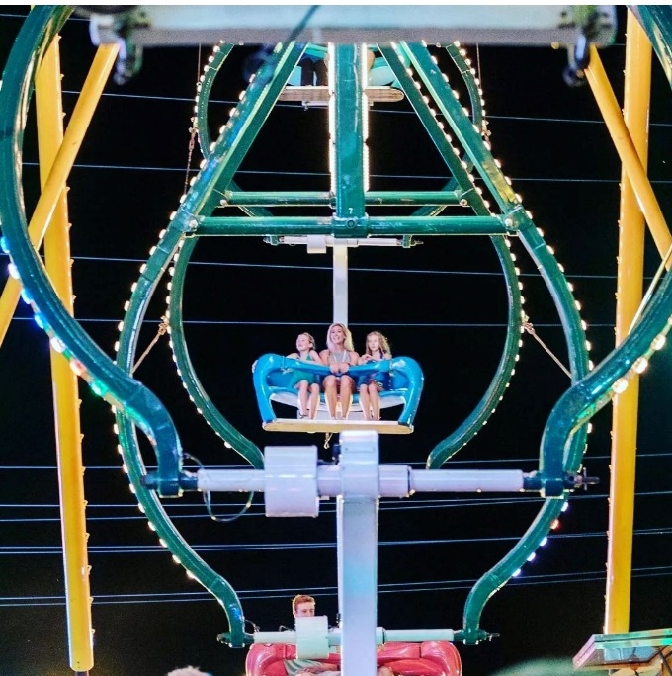
2.Enjoy all the rides, games and food the Great Anderson County Fair has to offer.

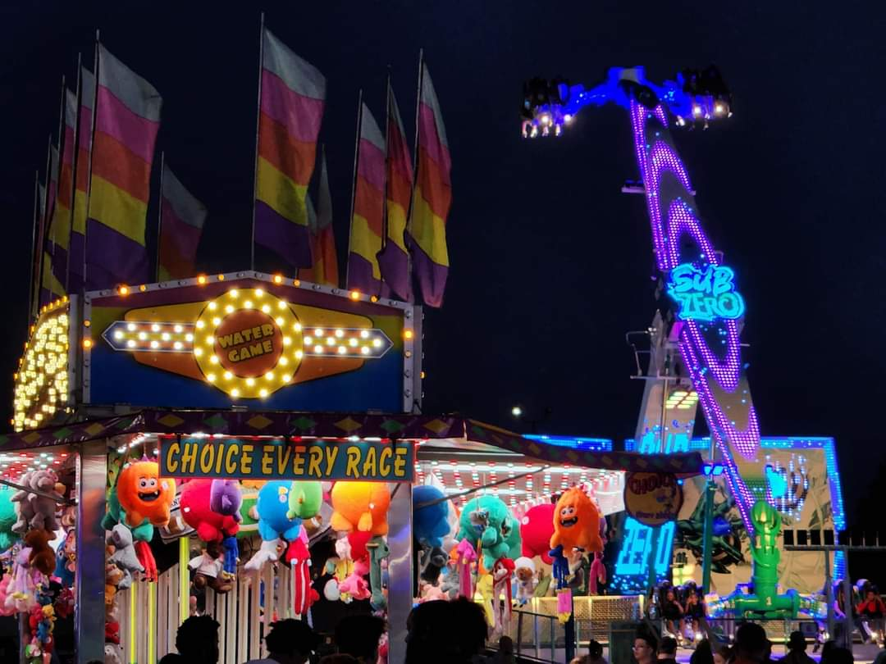

- Rosaire’s Royal Racers is a family friendly, interactive, snorting good time.
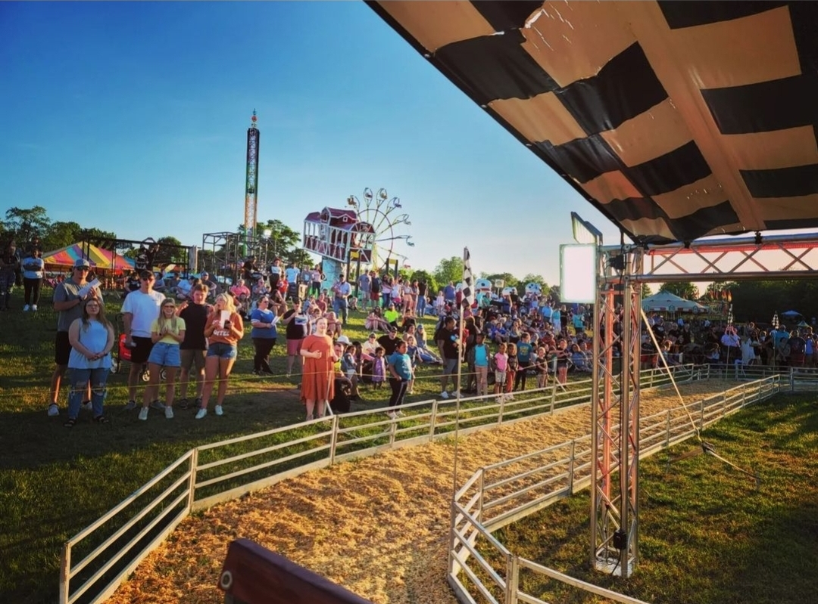

- Welcome to the Great Anderson County Fair!
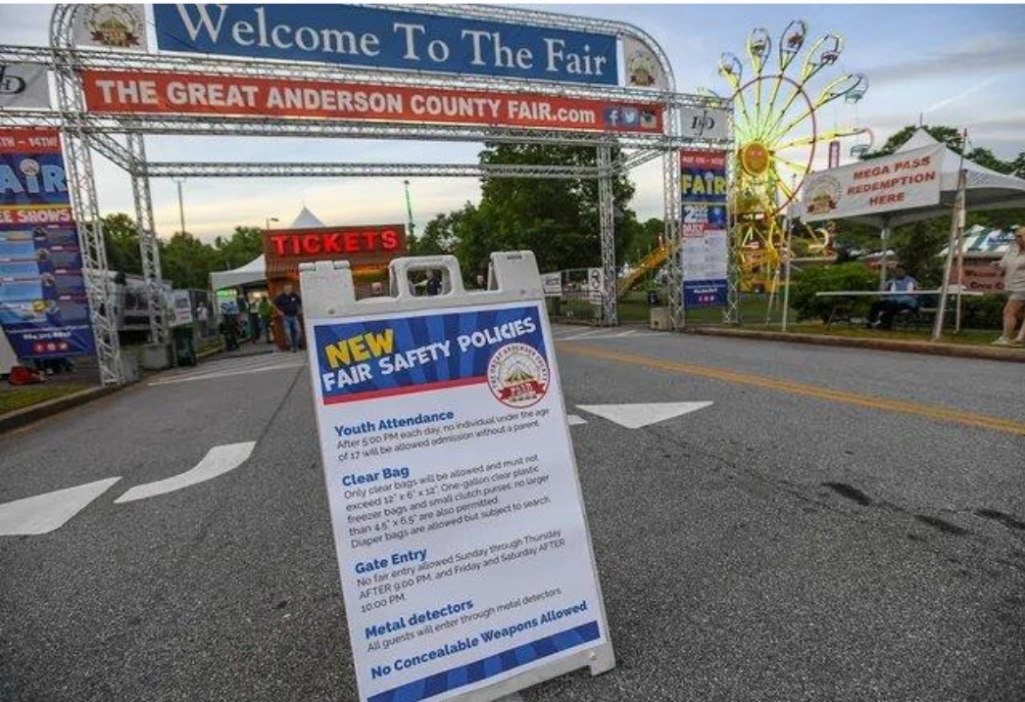

- The Seattle Wheel is the best place to see all the action
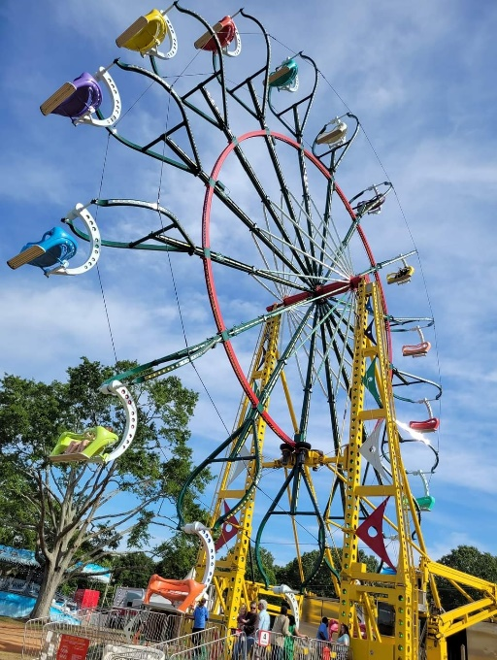

- Lady Houdini will be performing impossible feats
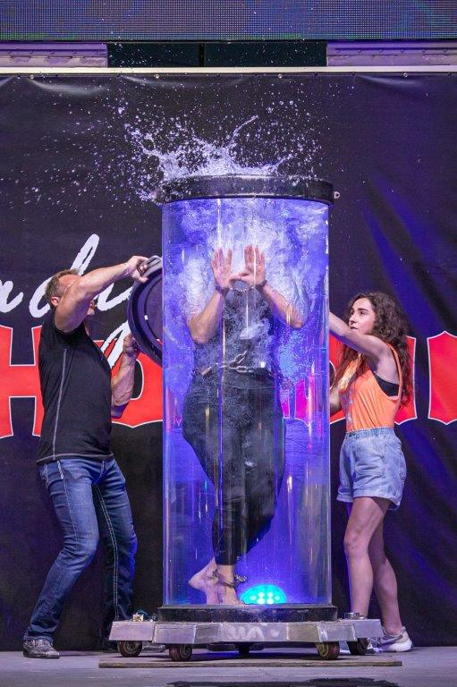

- Ready Go Dog Show will be delighting audiences daily
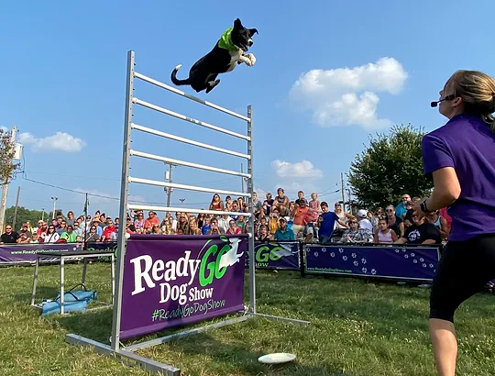
- Roasted corn is always a family favorite

